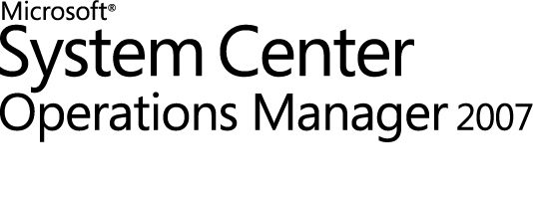

System Center Virtual Machine Manager 2008 R2 Self-Service Portal 2.0 SP1
Management Pack Guide
Microsoft Corporation
Published: June 2011
Send suggestions and comments about this document to mpgfeed@microsoft.com. Please include the management pack guide name with your feedback.

Copyright
Information in this document, including URL and other Internet Web site references, is subject to change without notice. Unless otherwise noted, the companies, organizations, products, domain names, e-mail addresses, logos, people, places, and events depicted in examples herein are fictitious. No association with any real company, organization, product, domain name, e-mail address, logo, person, place, or event is intended or should be inferred. Complying with all applicable copyright laws is the responsibility of the user. Without limiting the rights under copyright, no part of this document may be reproduced, stored in or introduced into a retrieval system, or transmitted in any form or by any means (electronic, mechanical, photocopying, recording, or otherwise), or for any purpose, without the express written permission of Microsoft Corporation.
Microsoft may have patents, patent applications, trademarks, copyrights, or other intellectual property rights covering subject matter in this document. Except as expressly provided in any written license agreement from Microsoft, the furnishing of this document does not give you any license to these patents, trademarks, copyrights, or other intellectual property.
© 2011 Microsoft Corporation. All rights reserved.
Microsoft, and MS-DOS, Windows, Windows Server, and Active Directory are trademarks of the Microsoft group of companies. All other trademarks are property of their respective owners.

Contents
System Center Virtual Machine Manager 2008 R2 Self-Service Portal 2.0 SP1 Management Pack Guide 4
Introduction to the VMMSSP Management Pack 4
What's New 5
Supported Configurations 5
Getting Started 5
Before You Import the Management Pack 5
Files in This Management Pack 6
How to Import the VMMSSP Management Pack 6
Create a New Management Pack for Customizations 6
Security Considerations 7
Understanding Management Pack Operations 7
Objects the Management Pack Discovers 7
Classes 9
How Health Rolls Up 10
Key Monitoring Scenarios 12

System Center Virtual Machine Manager 2008 R2 Self-Service Portal 2.0 SP1
Management Pack Guide
The Microsoft® System Center Virtual Machine Manager 2008 R2 Self-Service Portal 2.0 SP1 (VMMSSP) Management Pack helps you manage your self-service portal deployment by monitoring the health of the self-service portal components. For the self-service portal to function correctly, the components must function correctly. The VMMSSP Management Pack alerts you about problems with these components so that you can troubleshoot and repair any problems that occur.
Using the VMMSSP Management Pack helps centralize the overall monitoring in the organization to one location, the Operations console. The management pack also provides instructions to end users about how to repair some problems that might be detected while monitoring. This simplifies maintenance and could help reduce the number of support calls.
Document Version
This guide was written based on the original release of the VMMSSP Management Pack.
Revision History

Release Date | Changes
June 2011 | Original release of this guide

Introduction to the VMMSSP Management Pack
The VMMSSP Management Pack provides the classes, rules, and monitors necessary to monitor the health of the VMMSSP deployment. This management pack discovers the three components of VMMSSP (VMMSSP database component, VMMSSP server component, and VMMSSP website component) as well as the Virtual Machine Manager server that supports VMMSSP. The management pack monitors the health state of the Virtual Machine Manager server and of the two services that comprise the VMMSSP server component (Virtual Machine Manager Self-Service Portal 2.0 service and Virtual Machine Manager Self-Service Portal 2.0 Helper service). The management pack rules capture the most important events that the VMMSSP server component generates, and generate alerts based on that information.
Getting the Latest Management Pack and Documentation
You can find the VMMSSP Management Pack in the System Center Operations Manager 2007 Catalog (http://go.microsoft.com/fwlink/?LinkId=82105).

What's New
The following features are new in this release of the VMMSSP Management Pack:
- Capturing critical events from the self-service portal and creating corresponding alerts in System Center Operations Manager 2007 R2.
• Monitoring the health of the self-service portal components and providing users with a real-time health status.
• Providing Operations Manager–integrated knowledge for events.
• Ensuring that the management pack provides clear health information, and that it is extensible, allowing users to add objects such as monitors, overrides, tasks, and knowledge.

Supported Configurations
The VMMSSP Management Pack supports all configurations that are supported by the self-service portal.
The following table describes the supported configurations for the VMMSSP Management Pack:

Configuration | Support
All self-service portal components installed on a single computer | Yes
Each self-service portal component installed on a separate computer | Yes
Agentless monitoring | Yes
Virtual environment | Yes

Getting Started
This section describes the prerequisites for the VMMSSP Management Pack, the contents of the management pack package file, information about importing the management pack, and information about customizations. The VMMSSP Management Pack does not require any additional configuration after you import it.

Before You Import the Management Pack
There are no special hardware or system requirements, other than what is required for Operations Manager 2007 R2.
To use the VMMSSP Management Pack, you must have a working deployment of Operations Manager 2007 R2.
Before you import the VMMSSP Management Pack, make sure you have imported the following management packs:
- Microsoft.SQLServer.2008.Discovery Version(6.0.6794.0) or later
- Microsoft.SQLServer.2008.Monitoring Version(6.1.314.36) or later
- Microsoft.SQLServer.Library Version(6.1.314.36) or later
- Microsoft.Windows.InternetInformationServices.2008 Version(6.0.7600.0) or later
- Microsoft.Windows.InternetInformationServices.CommonLibrary Version(6.0.6658.0) or later
- Microsoft.Windows.Server.2008.Discovery Version(6.0.6794.0) or later
Important In addition to importing the management packs listed previously, we recommend that you import the Message Queueing Management Pack (Microsoft.MSMQ.2008R2) and use it to monitor the message queues on the servers that run the VMMSSP components.

Files in This Management Pack
The VMMSSPManagementPack.msi package file contains the VMMSSP Management Pack. It includes the following files:
• Microsoft.SystemCenter.VMMSSP.mp
• MP-VMMSSP-EULA.rtf

How to Import the VMMSSP Management Pack
For instructions about importing a management pack, see How to Import a Management Pack in Operations Manager 2007 (http://go.microsoft.com/fwlink/?LinkId=142351).
After the VMMSSP Management Pack is imported, create a new management pack in which you store overrides and other customizations.

Create a New Management Pack for Customizations
Most vendor management packs are sealed so that you cannot change any of the original settings in the management pack file. However, you can create customizations, such as overrides or new monitoring objects, and save them to a different management pack. By default, Operations Manager 2007 saves all customizations to the Default Management Pack. As a best practice, you should instead create a separate management pack for each sealed management pack you want to customize.
Creating a new management pack for storing overrides has the following advantages:
• It simplifies the process of exporting customizations that were created in your test and pre-production environments to your production environment. For example, instead of exporting the Default Management Pack that contains customizations from multiple management packs, you can export just the management pack that contains customizations of a single management pack.
• You can delete the original management pack without first needing to delete the Default Management Pack. A management pack that contains customizations is dependent on the original management pack. This dependency requires you to delete the management pack with customizations before you can delete the original management pack. If all of your customizations are saved to the Default Management Pack, you must delete the Default Management Pack before you can delete an original management pack.
• It is easier to track and update customizations to individual management packs.
For more information about sealed and unsealed management packs, see Management Pack Formats (http://go.microsoft.com/fwlink/?LinkId=108355). For more information about management pack customizations and the Default Management Pack, see About Management Packs in Operations Manager 2007 (http://go.microsoft.com/fwlink/?LinkId=108356).

Security Considerations
The VMMSSP Management Pack does not require any special security considerations.

Run As Profiles
When it requires a Run as profile, the VMMSSP Management Pack uses the System Center Virtual Machine Manager Self-Service Portal Database Query Account. This Run as profile should have sufficient permissions to read the registries of the computers that run the VMMSSP components, and to read the DITSC database.

Understanding Management Pack Operations
The VMMSSP Management Pack monitors the health of the VMMSSP components. This section provides information that describes how this management pack works.

Objects the Management Pack Discovers
The VMMSSP Management Pack discovers the object types described in the following table. By default, discovery occurs every four hours.
Table 1. Discovery Processes used by the VMMSSP Management Pack

Discovery | Search | Populate Objects of Type
Microsoft.SystemCenter.  VMMSSP.  ProvisioningService.  Discovery | Search the registries of the known Windows®-based computers.  If the registry subkey Software\Microsoft\DITSC\ exists and the value of the subkey’s entry DITSC_Service is 1, retrieve the values of the entries under the subkey. | Microsoft.SystemCenter.  VMMSSP.  ProvisioningService
Microsoft.SystemCenter.  VMMSSP.HelperService.  Discovery | Search the registries of the known Windows-based computers.  If the registry subkey Software\Microsoft\DITSC\ exists and the value of the subkey’s entry DITSC_Service is 1, retrieve the values of the entries under the subkey. | Microsoft.SystemCenter.  VMMSSP.HelperService
Microsoft.SystemCenter.  VMMSSP.Database.  Discovery | Search the registries of computers that have Microsoft.SystemCenter.VMMSSP.  ProvisioningService objects.  If the registry subkey Software\Microsoft\DITSC\ exists and the value of the subkey’s entry DITSC_Service is 1, retrieve the values of the entries under the subkey. | Microsoft.SystemCenter.  VMMSSP.Database
Microsoft.SystemCenter.  VMMSSP.WebPortal.  Discovery | Search the registries of the known Windows-based computers.  If the registry subkey Software\Microsoft\DITSC\ exists and the value of the subkey’s entry DITSC_Web is 1, retrieve the values of the entries under the subkey.  Search the known Internet Information Services (IIS) websites for the website identified in the registry (the website name is VMMSSP) | Microsoft.SystemCenter.  VMMSSP.WebPortal
Microsoft.SystemCenter.  VMMSSP.  VMMServerComponent.  Discovery | Retrieve the database information from the Microsoft.SystemCenter.VMMSSP.  Database object, and connect to the database.  In the DITSC database, search the Server Role table for the VMM server name.  Important This process uses a Run as profile to connect to the DITSC database. By default, the process uses the System Center Virtual Machine Manager Self-Service Portal Database Query Account. If you change the Run as profile, be sure to use a profile that has at least Read permission on the database. | Microsoft.SystemCenter.  VMMSSP.  VMMServerComponent
Microsoft.SystemCenter.  VMMSSP.InstanceGroup.  DiscoveryRule | Collect the populated objects of type Microsoft.SystemCenter.VMMSSP.  ProvisioningService, Microsoft.SystemCenter.VMMSSP.  HelperService, and Microsoft.SystemCenter.VMMSSP.  VMMServerComponent. | Microsoft.SystemCenter.  VMMSSP.  InstanceGroup

Classes
The following diagram shows the classes defined in this management pack. Shaded boxes indicate classes that are defined in other management packs; the management pack that defines a class is listed in parentheses.

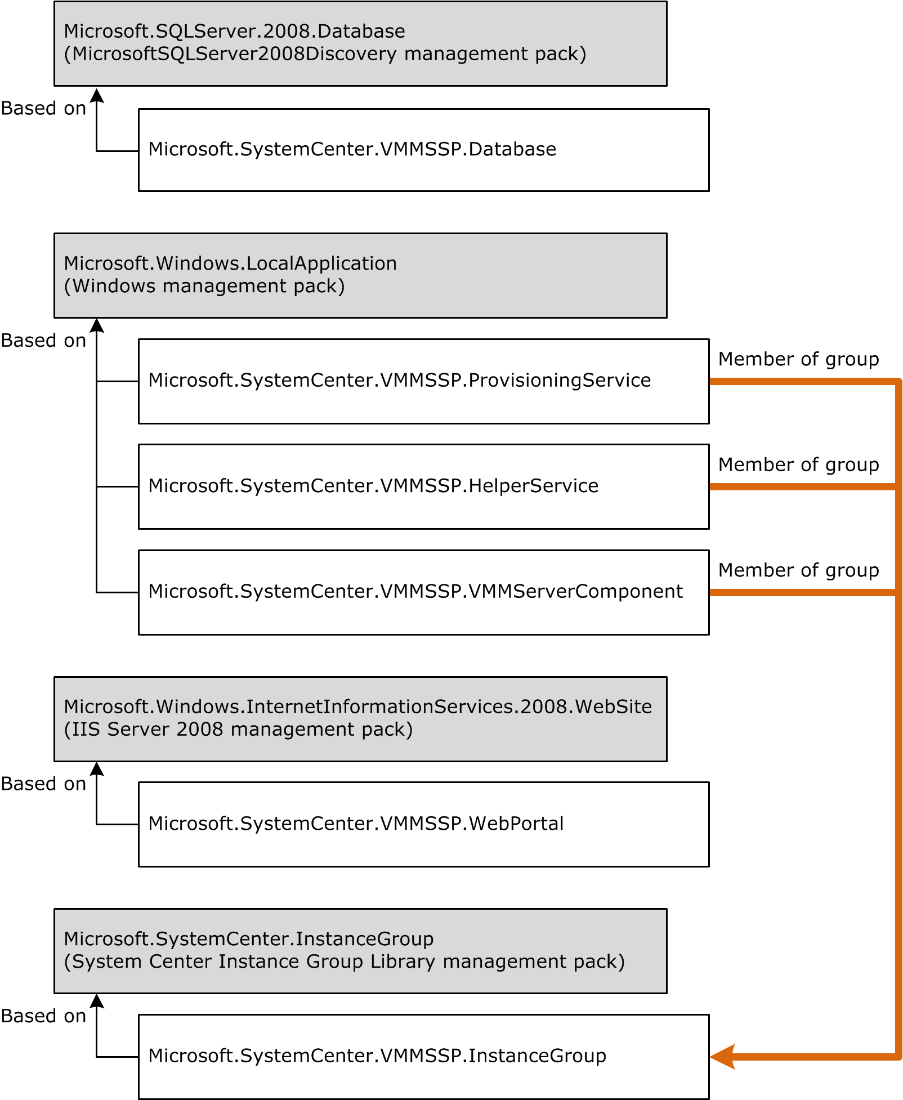
Figure 1. Classes defined in this management pack

How Health Rolls Up
This management pack uses three monitors and five rules to provide health information. The health states of the different components do not interact.
The VMMSSP Management Pack does not provide custom functionality to monitor the health status of VMMSSP.WebPortal and VMMSSP.Database objects. This functionality is provided by the IIS Server 2008 and SQL Server 2008 management packs, respectively.
Table 2. Health State Changes That Generate Alerts

Object Type | State | Alert
Microsoft.SystemCenter.  VMMSSP.ProvisioningService | Running | None
 | Not running | Virtual Machine Manager Self-Service Portal 2.0 service has stopped.
Microsoft.SystemCenter.  VMMSSP.HelperService | Running | None
 | Not running | Virtual Machine Manager Self-Service Portal 2.0 Helper service has stopped.
Microsoft.SystemCenter.  VMMSSP.VMMServerComponent | Running | None
 | Not running | Virtual Machine Manager service has stopped.
Table 3. Events That Generate Alerts

Component | Event ID | Alert
Microsoft.SystemCenter.  VMMSSP.ProvisioningService | 1007  1008  1011  1012  1013 | Event {0}: The requesting user is not authorized to complete the operation.
 | 1423 | Event 1423: Cannot connect to the requested VMM server.
 | 1425 | Event 1425: Error reading the credentials from registry.
 | 1603 | Event 1603: Cannot assign the Connect permission to the user who is trying to connect to the requested virtual machine.
Microsoft.SystemCenter.  VMMSSP.HelperService | 6011 | Event 6011: Error reading the credentials from registry.

Key Monitoring Scenarios
The VMMSSP Management Pack provides seven pre-defined views of VMMSSP health and status information. These views support the following monitoring scenarios:
- Monitoring active and closed alerts for all VMMSSP components.
- Monitoring the server functions (services underlying the VMMSSP server component and Virtual Machine Manager).
- Monitoring the VMMSSP database component.
- Monitoring the VMMSSP website component.
Table 4. Monitoring Active and Closed Alerts

View | Description | Monitored Objects | Rules and Monitors That Provide Data for This View
Active Alerts  (Microsoft.  SystemCenter.  VMMSSP.  ActiveAlert) | Lists unresolved alerts associated with objects that are members of the Microsoft.  SystemCenter.VMMSSP.  InstanceGroup object. | Microsoft.  SystemCenter.  VMMSSP.  ProvisioningService  Microsoft.  SystemCenter.  VMMSSP.  HelperService  Microsoft.  SystemCenter.  VMMSSP.  VMMServerComponent | Microsoft.SystemCenter.  VMMSSP.Event.1011  Microsoft.SystemCenter.  VMMSSP.Event.1423  Microsoft.SystemCenter.  VMMSSP.Event.1425  Microsoft.SystemCenter.  VMMSSP.Event.1603  Microsoft.SystemCenter.  VMMSSP.Event.6011  Microsoft.SystemCenter.  VMMSSP.  ProvisioningService.  Monitor  Microsoft.SystemCenter.  VMMSSP.HelperService.  Monitor  Microsoft.SystemCenter.  VMMSSP.VMMServer.  Service.Monitor
Closed Alerts  (Microsoft.  SystemCenter.  VMMSSP.  ClosedAlerts) | Lists resolved alerts associated with objects that are members of the Microsoft.  SystemCenter.VMMSSP.  InstanceGroup object. | Microsoft.  SystemCenter.  VMMSSP.  ProvisioningService  Microsoft.  SystemCenter.  VMMSSP.  HelperService  Microsoft.  SystemCenter.  VMMSSP.  VMMServerComponent | Microsoft.SystemCenter.  VMMSSP.Event.1011  Microsoft.SystemCenter.  VMMSSP.Event.1423  Microsoft.SystemCenter.  VMMSSP.Event.1425  Microsoft.SystemCenter.  VMMSSP.Event.1603  Microsoft.SystemCenter.  VMMSSP.Event.6011  Microsoft.SystemCenter.  VMMSSP.  ProvisioningService.  Monitor  Microsoft.SystemCenter.  VMMSSP.HelperService.  Monitor  Microsoft.SystemCenter.  VMMSSP.VMMServer.  Service.Monitor

Table 5. Monitoring Server Functions (VMMSSP Server Component and VMM Server)

View | Description | Monitored Objects | Rules and Monitors That Provide Data for This View
VMMSSP Service State  (Microsoft.  SystemCenter.  VMMSSP.  Provisioning  ServiceView) | Lists all alerts (resolved or unresolved) associated with the Virtual Machine Manager Self-Service Portal 2.0 service, and lists the health state of the service. | Microsoft.  SystemCenter.  VMMSSP.  ProvisioningService | Microsoft.SystemCenter.  VMMSSP.Event.1011  Microsoft.SystemCenter.  VMMSSP.Event.1423  Microsoft.SystemCenter.  VMMSSP.Event.1425  Microsoft.SystemCenter.  VMMSSP.Event.1603  Microsoft.SystemCenter.  VMMSSP.  ProvisioningService.  Monitor
VMMSSP Helper Service State  (Microsoft.  SystemCenter.  VMMSSP.Helper  ServiceView) | Lists all alerts (resolved or unresolved) associated with the Virtual Machine Manager Self-Service Portal 2.0 Helper service, and lists the health state of the service. | Microsoft.  SystemCenter.  VMMSSP.  HelperService | Microsoft.SystemCenter.  VMMSSP.Event.6011  Microsoft.SystemCenter.  VMMSSP.  HelperService.  Monitor
Virtual Machine Manager State  (Microsoft.  SystemCenter.  VMMSSP.  VMMServersView) | Lists the health state of the Virtual Machine Manager service. | Microsoft.  SystemCenter.  VMMSSP.  VMMServerComponent | Microsoft.SystemCenter.  VMMSSP.VMMServer.  Service.Monitor

Table 6. Monitoring the VMMSSP Database Component

View | Description | Monitored Objects | Rules and Monitors That Provide Data for This View
VMMSSP Database Component State  (Microsoft.  SystemCenter.  VMMSSP.  Database.State.  View) | Lists the health state of the DITSC database (the SQL Server® database used by VMMSSP). | Microsoft.  SystemCenter.  VMMSSP.Database | Monitors for the parent class of this object are defined in the SQL Server 2008 management packs.*
* For a list of the SQL Server 2008 management packs that this management pack uses, see the “Before You Import the Management Pack” section earlier in this guide.

Table 7. Monitoring the VMMSSP Website Component

View | Description | Monitored Objects | Rules and Monitors That Provide Data for This View
VMMSSP Website Component State  (Microsoft.  SystemCenter.  VMMSSP.  WebSiteComponent.  StateView) | Lists the health state of the VMMSSP website. | Microsoft.  SystemCenter.  VMMSSP.  WebPortal | Monitors for the parent class of this object are defined in the IIS Server 2008 management packs.**
** For a list of the IIS Server 2008 management packs that this management pack uses, see the “Before You Import the Management Pack” section earlier in this guide.
Important If the VMMSSP website or its application pool are deleted from IIS, the VMMSSP Website Component State view still shows the WebPortal object to be healthy. The available rules and monitors cannot detect these deletions.

